G VENKATA SRIDHAR  gvsridhar.devops@gmail.com
+91-9739964629

Jenkins Interview Questions

Question: What is Jenkins?

Answer: Jenkins is an open-source automation tool written in Java with plugins built for Continuous Integration purposes. Jenkins is used to build and test your software projects continuously making it easier for developers to integrate changes to the project, and making it easier for users to obtain a fresh build. It also allows you to continuously deliver your software by integrating with a large number of testing and deployment technologies.

Question: Define the process of Jenkins.

Answer:
• First, a developer commits the code to the source code repository. Meanwhile, the Jenkins server checks the repository at regular intervals for changes.
• Soon after a commit occurs, the Jenkins server detects the changes that have occurred in the source code repository. Jenkins will pull those changes and will start preparing a new build.
• If the build fails, then the concerned team will be notified.
• If the build is successful, then Jenkins deploys the build in the test server.
• After testing, Jenkins generates feedback and then notifies the developers about the build and test results.
• It will continue to check the source code repository for changes made in the source code and the whole process keeps on repeating.
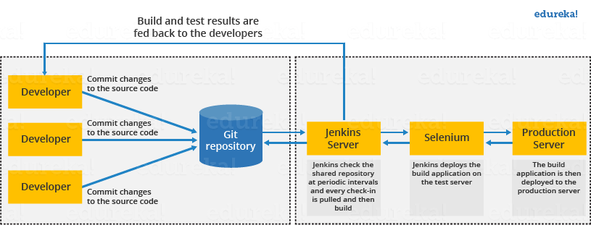

Question: What is the use of JENKINS HOME directory?

Answer: All the settings, logs and configurations are stored in the JENKINS_HOME directory.

Question: What are the benefits of using Jenkins?

Answer:
• At the integration stage, you can cache build failures.
• For each change in the source code, you generate an automatic build report notification.
• To notify developers about build report success or failure, Jenkins integrates with the LDAP mail server.
• Achieves continuous integration agile development and test-driven development.
• With simple steps, you can automate the maven release project.
• Easy tracking of bugs at an early stage in a development environment than production.

Question: What are the types of pipelines in Jenkins?

Answer: There are 3 types –
1.CI CD pipeline (Continuous Integration Continuous Delivery)
2.Scripted pipeline
3.Declarative pipeline

Question: Mention some of the useful plugins in Jenkins?
How can you integrate Jenkins with DevOps Tools?

Answer: Below I have mentioned some important Plugins: Go to Manage plugins section and add plugins as per our CICD requirements. Below are the few plugins list.

• Maven, SonarQube, JMeter, Git, Docker, Kubernetes, Artifactory, Credentials, Selenium.

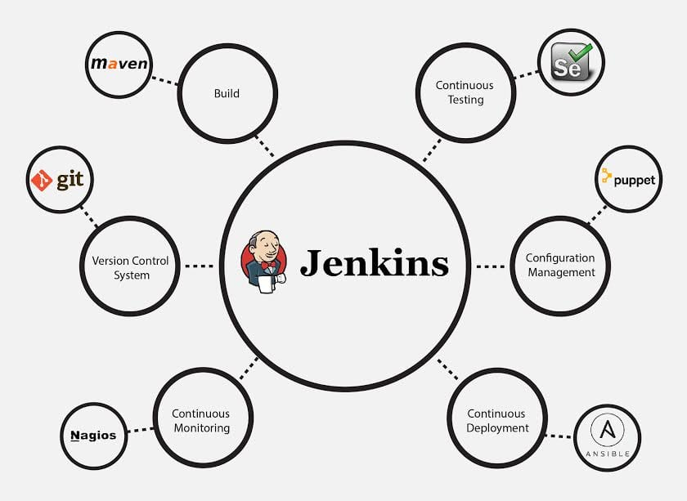

Question: How does Jenkins authenticate users?

Answer: There are 3 ways –
• The default way is to store user data and credentials in an internal database.
• Configure Jenkins to use the authentication mechanism defined by the application server on which it is deployed.
• Configure Jenkins to authenticate against LDAP server.

Question: Explain how you can set up Jenkins job?
how to create Jenkins job?
Answer: Go to Jenkins top page, select “New Job”, then choose “Build a free-style software project”.
Now you can tell the elements of this freestyle job:
• Optional SCM, such as CVS or Subversion where your source code resides.
• Optional triggers to control when Jenkins will perform builds.
• Some sort of build script that performs the build (ant, maven, shell script, batch file, etc.) where the real work happens.
• Optional steps to collect information out of the build, such as archiving the artifacts and/or recording javadoc and test results.
• Optional steps to notify other people/systems with the build result, such as sending e-mails, IMs, updating issue tracker, etc.

Question: How to create a backup and copy files in Jenkins?

Answer: To create a backup all you need to do is to periodically back up your JENKINS_HOME directory. This contains all of your build jobs configurations, your slave node configurations, and your build history. To create a back-up of your Jenkins setup, just copy this directory. You can also copy a job directory to clone or replicate a job or rename the directory.

Question: How will you secure Jenkins?

Answer: The way I secure Jenkins is mentioned below if you have any other way to do it than mention that:
• Make sure that the global security is on.
• Check if Jenkins is integrated with my company’s user directory with an appropriate plugin.
• Ensure that the matrix/Project matrix is enabled to fine-tune access.
• Automate the process of setting rights/privileges in Jenkins with custom version-controlled script.
• Limit physical access to Jenkins data/folders.
• Periodically run security audits on the same.

Question: How will you define Post in Jenkins?

Answer: Post is a section that contains several additional steps that might execute after the completion of the pipeline. The execution of all the steps within the condition block depends upon the completion status of the pipeline. The condition block includes the following conditions – changed success, always, failure, unstable and aborted.

Question: Explain how you can deploy a custom build of a core plugin?

Answer: Below are the steps to deploy a custom build of a core plugin:
• Stop Jenkins.
• Copy the custom HPI to $Jenkins_Home/plugins.
• Delete the previously expanded plugin directory.
• Make an empty file called <plugin>.hpi.pinned.
• Start Jenkins.

Question: What you do when you see a broken build for your project in Jenkins?

Answer: I will open the console output for the broken build and try to see if any file changes were missed. If I am unable to find the issue that way, then I will clean and update my local workspace to replicate the problem on my local and try to solve it.

Question: What are the various ways in which build can be scheduled in Jenkins?

Answer: You can schedule a build in Jenkins in the following ways:
• By source code management commits
• After completion of other builds
• Can be scheduled to run at a specified time (crons)
• Manual Build Requests

Question: What is the use of Pipelines in Jenkins?

Answer: Pipeline plugin is used in Jenkins for making the Jenkins Pipeline, which gives us the view of stages or tasks to perform one after the other in the pipeline form. It models a series of related tasks. Pipelines help the teams to review, edit and iterate upon the tasks. Pipelines are durable and it can optionally stop and wait for human approval as well to start the next task. A pipeline is extensible and can perform work in parallel. It supports complex CD requirements.

Question: Explain the terms Agent, Post-Section, Jenkinsfile?

Answer:
Agent: It is directive to tell Jenkins to execute the pipeline in a particular manner and order.

Post-section: If we have to add some notification and to perform other tasks at the end of a pipeline, post-section will definitely run at the end of every pipeline’s execution.

Jenkinsfile: The text file where all the definitions of pipelines are defined is called Jenkinsfile. It is being checked in the source control repository.

Question: Have you run automated tests on Jenkins? How is it done?

Answer: Yes, this can be done easily. Automated tests can be run through tools like Selenium or maven. Developers can schedule the test runs. Jenkins displays the test results and sends a report to the developers.

Question: While running a Pipeline, the first job was successful, but the second failed. What should you do next?

Answer: We need to restart the pipeline from the point where it failed by doing ‘restart from stage’.

Question: What do you mean by Pipeline as a Code?

Answer: Pipeline as Code describes a set of features that allow Jenkins users to define pipelined job processes with code, stored and versioned in a source repository. These features allow Jenkins to discover, manage, and run jobs for multiple source repositories and branches — eliminating the need for manual job creation and management.

To use Pipeline as Code, projects must contain a file named Jenkinsfile in the repository root, which contains a “Pipeline script.”

Additionally, one of the enabling jobs needs to be configured in Jenkins:

Multibranch Pipeline: build multiple branches of a single repository automatically

Organization Folders: scan a GitHub Organization or Bitbucket Team to discover an organization’s repositories, automatically creating managed Multibranch Pipeline jobs for them

Question: What is the difference between Continuous Delivery and Continuous Deployment?

Answer:
Continuous Delivery: (Manual Deployment to Production. Does not involve every change to be deployed.). Continuous Delivery is a software development practice where you build software in such a way that the software can be released to the production at any time. You achieve Continuous Delivery by continuously integrating the products built by the development team, running automated tests on those built products to detect problems and then push those files into production-like environments to ensure that the software works in production.
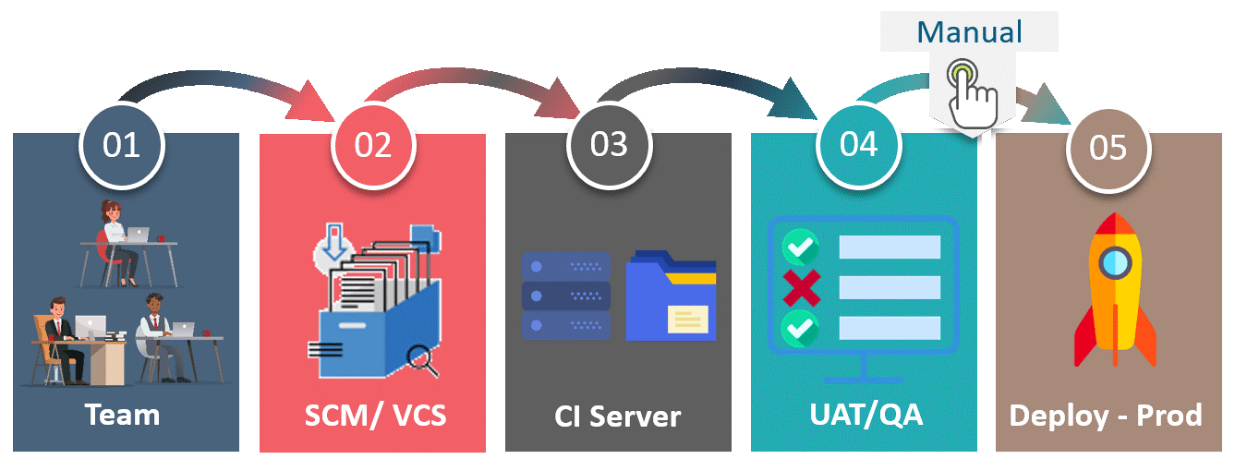

Continuous Deployment: (Automated Deployment to Production. Involves deploying every change automatically). Continuous deployment means that every change that you make, goes through the pipeline, and if it passes all the tests, it automatically gets deployed into production. So, with this approach, the quality of the software release completely depends on the quality of the test suite as you have automated everything.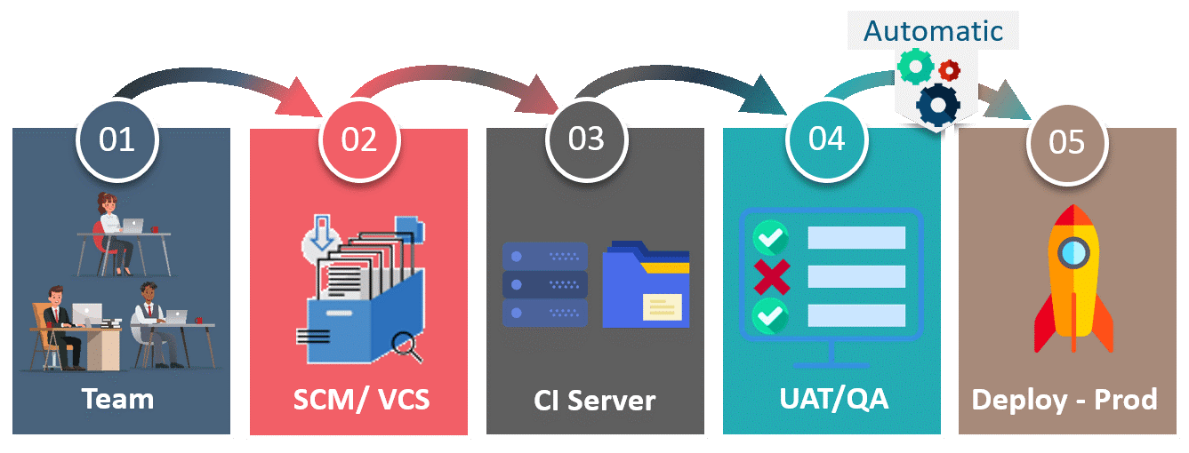

Question: Can you define a Continuous Delivery Workflow?

Answer: 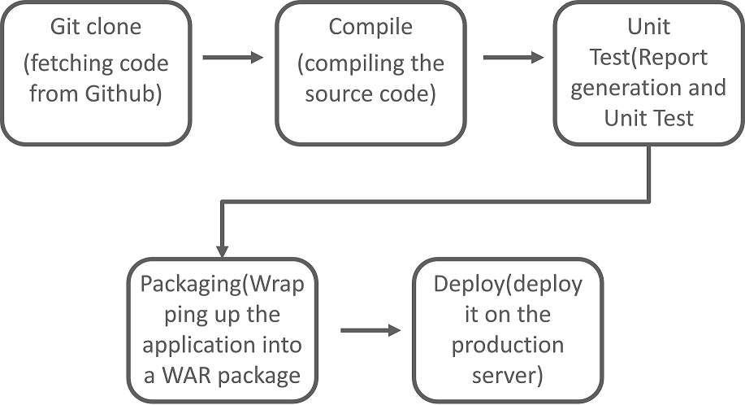

Question: How can you temporarily turn off Jenkins security if the administrative users have locked themselves out of the admin console?

Answer: The JENKINS_HOME folder contains a file named config.xml. When you enable the security, this file contains an XML element named useSecurity that changes to true. If you change this setting to false, security will be disabled the next time Jenkins is restarted.

<useSecurity>false</useSecurity>

However, we must understand that disabling security should always be both a last resort and a temporary measure. Once you resolve the authentication issues, make sure that you re-enable Jenkins security and reboot the CI server.

Question: Explain how you can move or copy Jenkins from one server to another?

Answer: I will approach this task by copying the jobs directory from the old server to the new one. There are multiple ways to do that, I have mentioned it below:

You can move a job from one installation of Jenkins to another by simply copying the corresponding job directory.

Make a copy of an existing job by making a clone of a job directory by a different name.

Rename an existing job by renaming a directory. Note that if you change a job name you will need to change any other job that tries to call the renamed job.

Question: What is Continuous Testing?

Answer: Continuous Testing is the process where you execute automated tests as part of the software delivery pipeline. This is done so that you get the feedback on the business risks associated with software as early as possible. It consists of evolving and extending test automation to address the increased complexity and pace of modern application development and delivery.

Continuous Testing means that testing takes place on a continuous basis without any disruption of any kind. In a Continuous DevOps process, a software change is continuously moving from Development to Testing to Deployment. The code undergoes continuous development, delivery, testing and deployment.

Question: How do you integrate Git with Jenkins?

Answer: These are the steps to integrate Git with Jenkins –

1.Click on the Manage Jenkins button on your Jenkins dashboard:
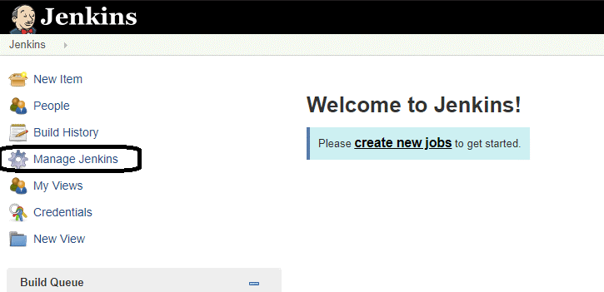

2. Click on Manage Plugins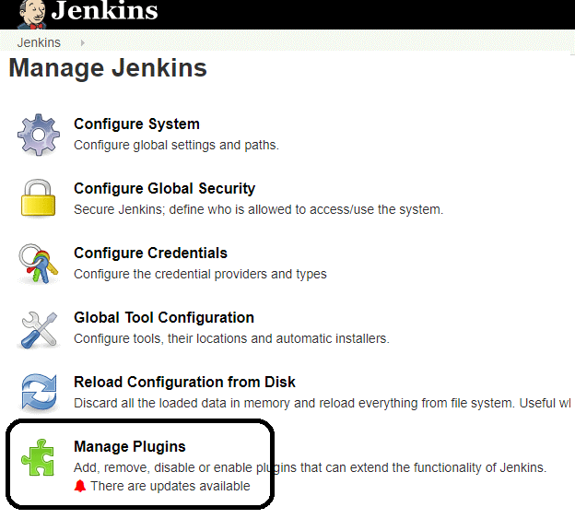

3. In the Plugins Page

Select the GIT Plugin, click on Install without restart. The plugin will take a few moments to finish downloading depending on your internet connection, and will be installed automatically. You can also select the option Download now and Install after restart. You will now see a “No updates available” message if you already have the Git plugin installed.

4. Once you install the plugins
Go to Manage Jenkins on your Jenkins dashboard. You will see your plugins listed among the rest.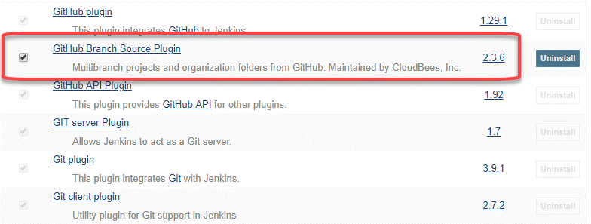

Question: What are the types of jobs or projects in Jenkins?

Answer: These are the types of jobs/projects in Jenkins –

Freestyle project
Maven project
Pipeline
Multibranch pipeline
External Job
Multi-configuration project
Github organization

Question: How do you create Multibranch Pipeline in Jenkins?

Answer: The Multibranch Pipeline project type enables you to implement different Jenkinsfiles for different branches of the same project. In a Multibranch Pipeline project, Jenkins automatically discovers, manages and executes Pipelines for branches that contain a Jenkinsfile in source control.

Question: What is a DSL Jenkins?

Answer: The Jenkins “Job DSL / Plugin” is made up of two parts – first, The Domain Specific Language (DSL) itself that allows users to describe jobs using a Groovy-based language, and second, a Jenkins plugin which manages the scripts and the updating of the Jenkins jobs which are created and maintained as a result.

Question: How do you achieve continuous integration using Jenkins?

Answer: Here are the steps –

All the developers commit their source code changes to the shared Git repository.
Jenkins server checks the shared Git repository at specified intervals and detected changes are then taken into the build.
The build results and test results are shared to the respective developers
The built application is displayed on a test server like Selenium and automated tests are run.
The clean and tested build is deployed to the production server.

Question: What is Continuous Integration in Jenkins?

Answer: In software development, multiple developers or teams work on different segments of the same web application. So, in this case, you have to perform integration testing by integrating all modules. In order to do that an automated process for each piece of code is performed on a daily bases so that all your codes get tested. This process is known as continuous integration.

Question: Name a Jenkins environment variable you have used in a shell script or batch file?

Answer: There are numerous environment variables that are available by default in any Jenkins build job. A few commonly used ones include:

$JOB_NAME
$NODE_NAME
$WORKSPACE
$BUILD_URL
$JOB_URL

Question: How do you create Multibranch Pipeline in Jenkins?

Answer: The Multibranch Pipeline project type enables you to implement different Jenkinsfiles for different branches of the same project. In a Multibranch Pipeline project, Jenkins automatically discovers, manages and executes Pipelines for branches that contain a Jenkinsfile in source control.

Question: How do you create Multibranch Pipeline in Jenkins?

Answer: The Multibranch Pipeline project type enables you to implement different Jenkinsfiles for different branches of the same project. In a Multibranch Pipeline project, Jenkins automatically discovers, manages and executes Pipelines for branches that contain a Jenkinsfile in source control.

Question: How do you create Multibranch Pipeline in Jenkins?

Answer: The Multibranch Pipeline project type enables you to implement different Jenkinsfiles for different branches of the same project. In a Multibranch Pipeline project, Jenkins automatically discovers, manages and executes Pipelines for branches that contain a Jenkinsfile in source control.

Question: How do you create Multibranch Pipeline in Jenkins?

Answer: The Multibranch Pipeline project type enables you to implement different Jenkinsfiles for different branches of the same project. In a Multibranch Pipeline project, Jenkins automatically discovers, manages and executes Pipelines for branches that contain a Jenkinsfile in source control.

